**G25 Preparative LCMS Operation Guide**

The operation of the preparative LCMS is identical to the analytical LCMS, with the addition of a fraction collector. Everything in this guide is identical to the analytical LCMS guide with the addition of the section called Fraction Collector Settings. Any sample run through the prep LCMS should first be first run on the analytical LCMS.

Table of Contents

LCMS Supplies from MyFinance 2

Prechecks Before Running a Sample 2

Sample Preparation 2

Creating a New Method 3

Fraction Collector Settings 5

Running a Single Injection 7

Running Sequence Injections 8

Viewing the Data 9

The waste container between the nitrogen generator and the argon cylinder collects the water condensate from the nitrogen generation. Make sure this is emptied into the sink before it gets too full

Solvent Tray (for isocratic pump)

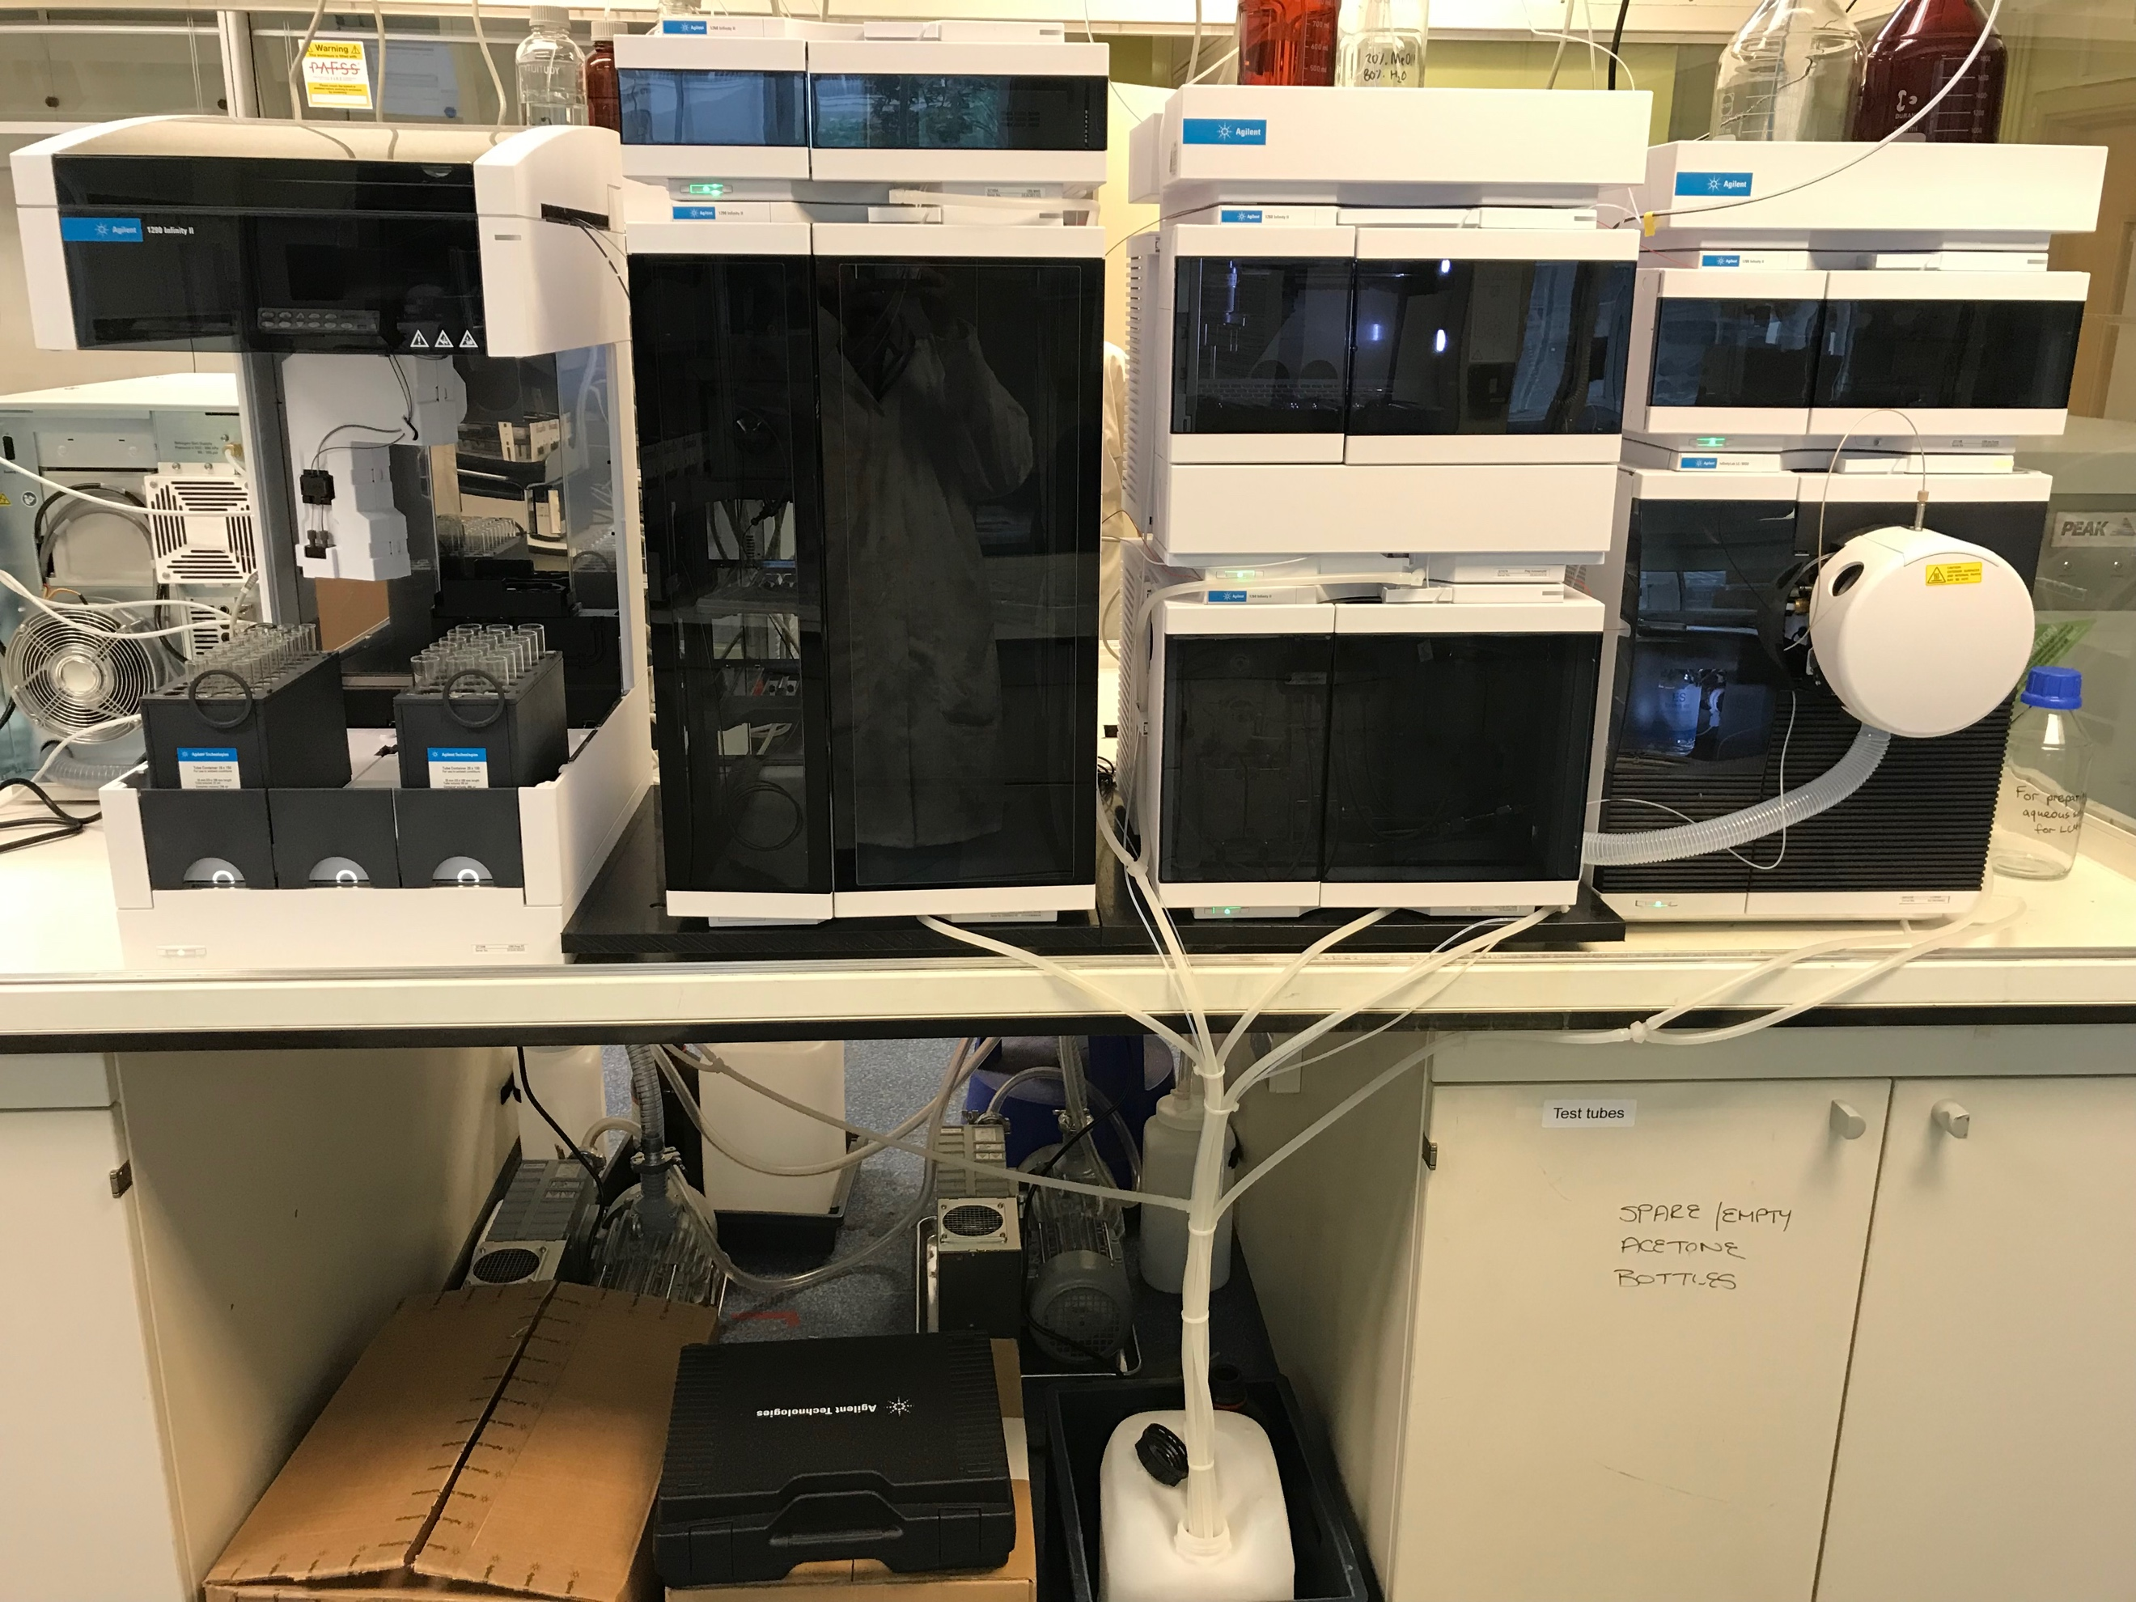

UV Detector

Solvent Tray (for main gradient)

# **LCMS Supplies from MyFinance**

Waste Container

Autosampler

Solvent Pump

Column Compartment

Fraction Collector

Mass Spectrometer

Isocratic Pump

* 2.5 L LCMS grade water (search for Cat no. 10777404)
* 2.5 L LCMS grade acetonitrile (search for Cat no. 10616653)
* Syringe filters (search for Cat no. ANN1322)
* 2 mL LCMS vials (search for Cat no. 5182-0716)
* LCMS vial caps (search for Cat no. 5190-7024)

# **Prechecks Before Running a Sample**

* Check the solvent volumes in the bottles above the LCMS
* If the solvent volume is low, remake the solution and top up the bottle
* ONLY use LCMS grade solvents
  + Line A is water w/ 0.1% formic acid
  + Line B is acetonitrile w/ 0.1% formic acid
* Once refilled, click the bottle icon and enter the new solvent volume

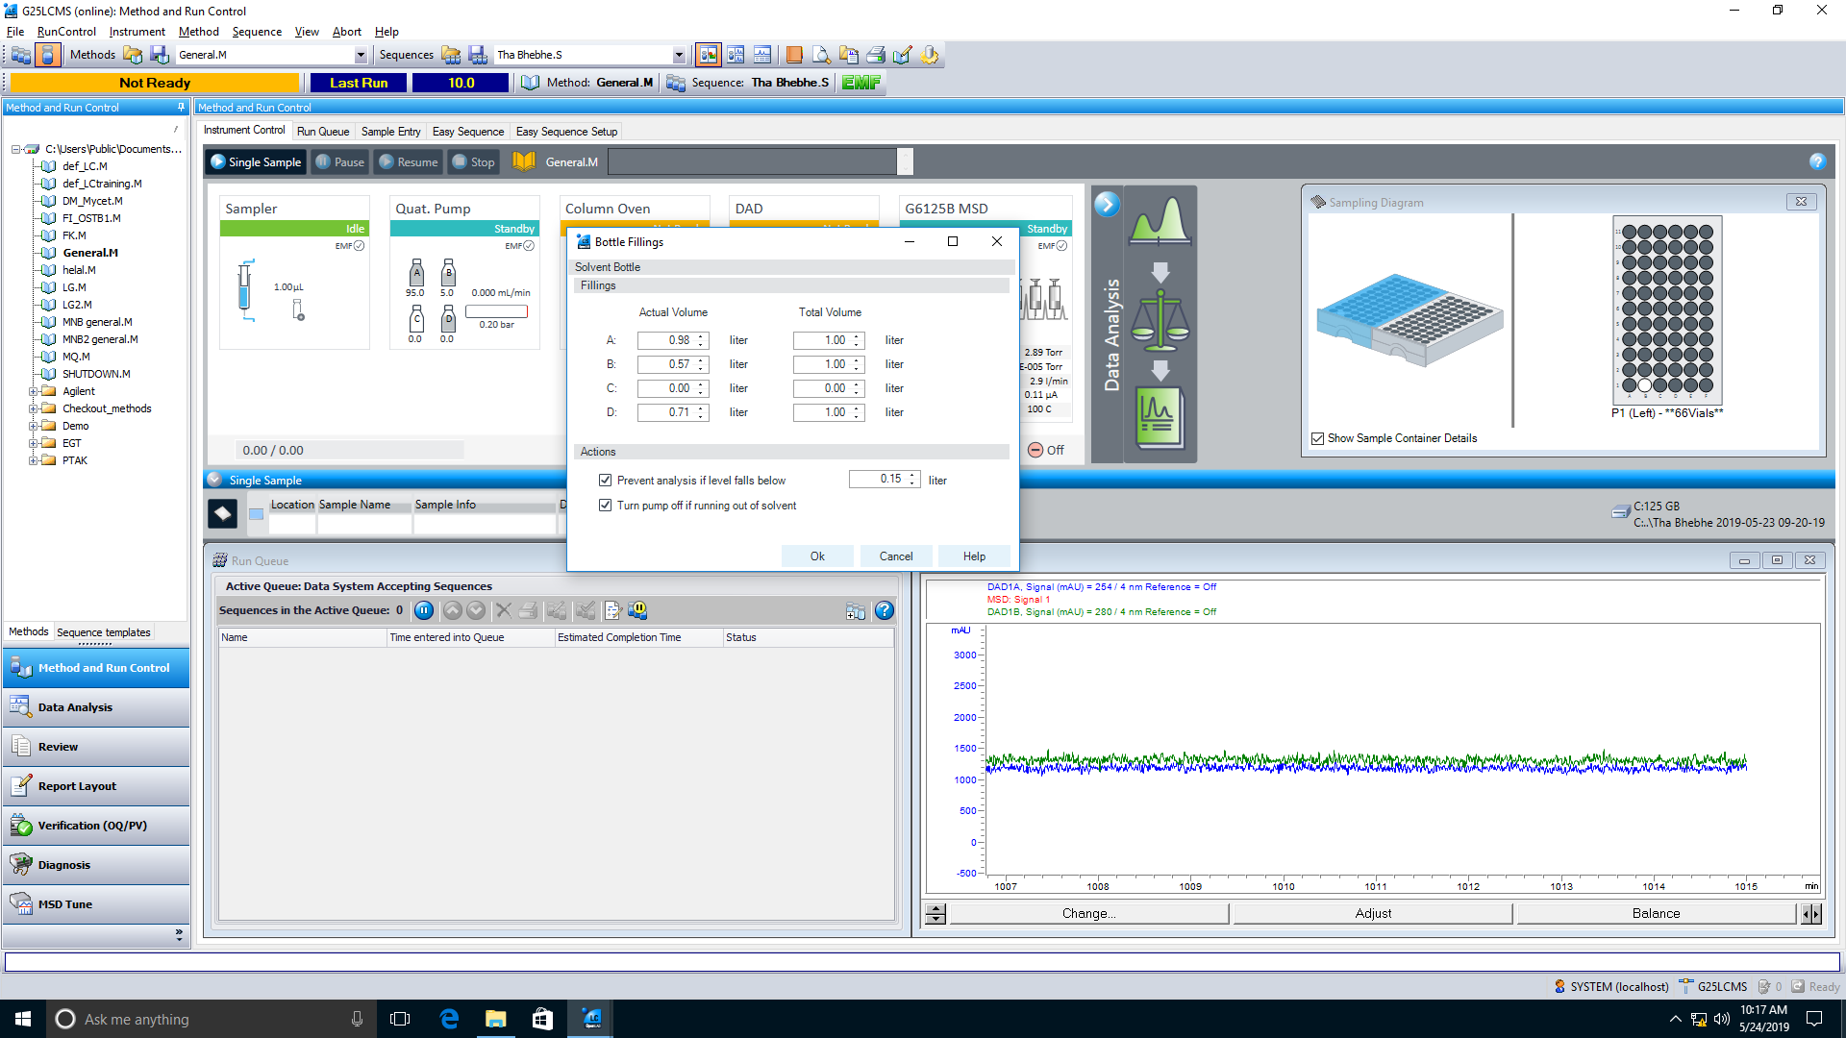

Click on the bottle icon to open the bottle fillings window

Enter the new solvent volumes here

* Check the fraction volumes of the tubes in the rack (see below for how to reset)
* Check the volume in the waste container under the prep LCMS
  + Replace with an empty waste container if full

# **Sample Preparation**

* For preparative LCMS, sample concentration can be higher than for analytical LCMS
* Keep in mind that injection of a more concentrated sample can affect peak shape and separation
* Ideally you want to prepare your sample in a solvent mixture that has less organic than the starting gradient percentage (i.e. if your gradient starts at 5% MeCN, dissolve your sample in this mixture)
* This may not always work so more MeCN can be used
* Filter this sample solution through a syringe filter into an LCMS vial
* Further dilute if necessary

# **Creating a New Method**

* Only edit your own methods (i.e. DO NOT edit another person’s method)
* The loaded method is indicated in bold
* To create a new method (and to save creating a method from scratch), right click on another person’s loaded method and choose Save Method As…
* Rename this to your initials­­

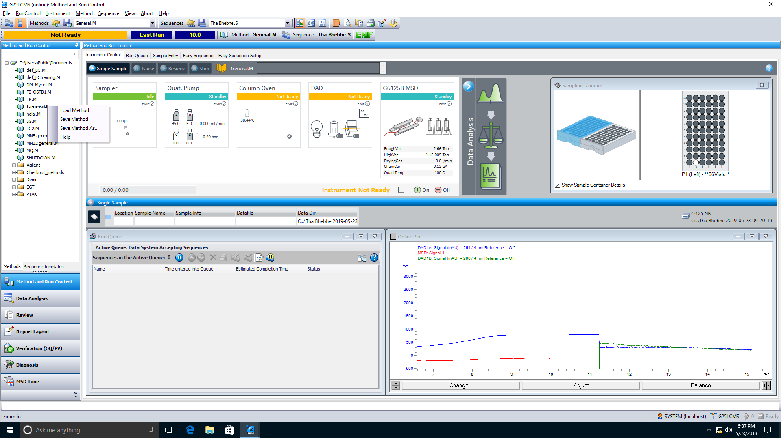

Right click an existing method and choose “Save Method As…”

Load a method by double clicking

Loaded method is in bold

* The method can be edited under Instrument => Set up instrument method…

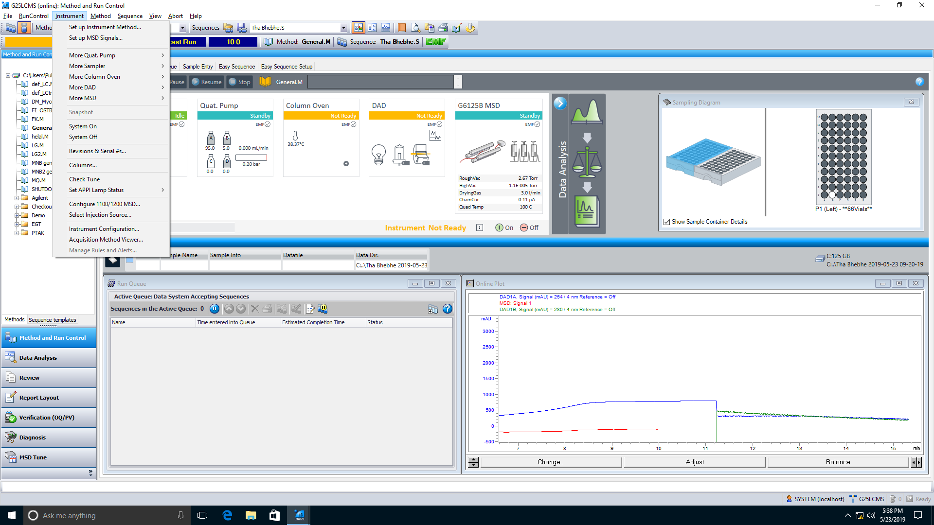

Edit the method gradient

Edit the mass detection parameters

* Edit the gradient as you see fit
* The Stoptime (time at which the data for a run will stop being collected) should be set as the last time point in your gradient
* The Posttime (time after a run has completed/time between sample injection in a sequence) should be set to at least 1 min
* The remaining tabs (sampler/sample injector program/column oven/dad/instrument curves) can be left with the default settings

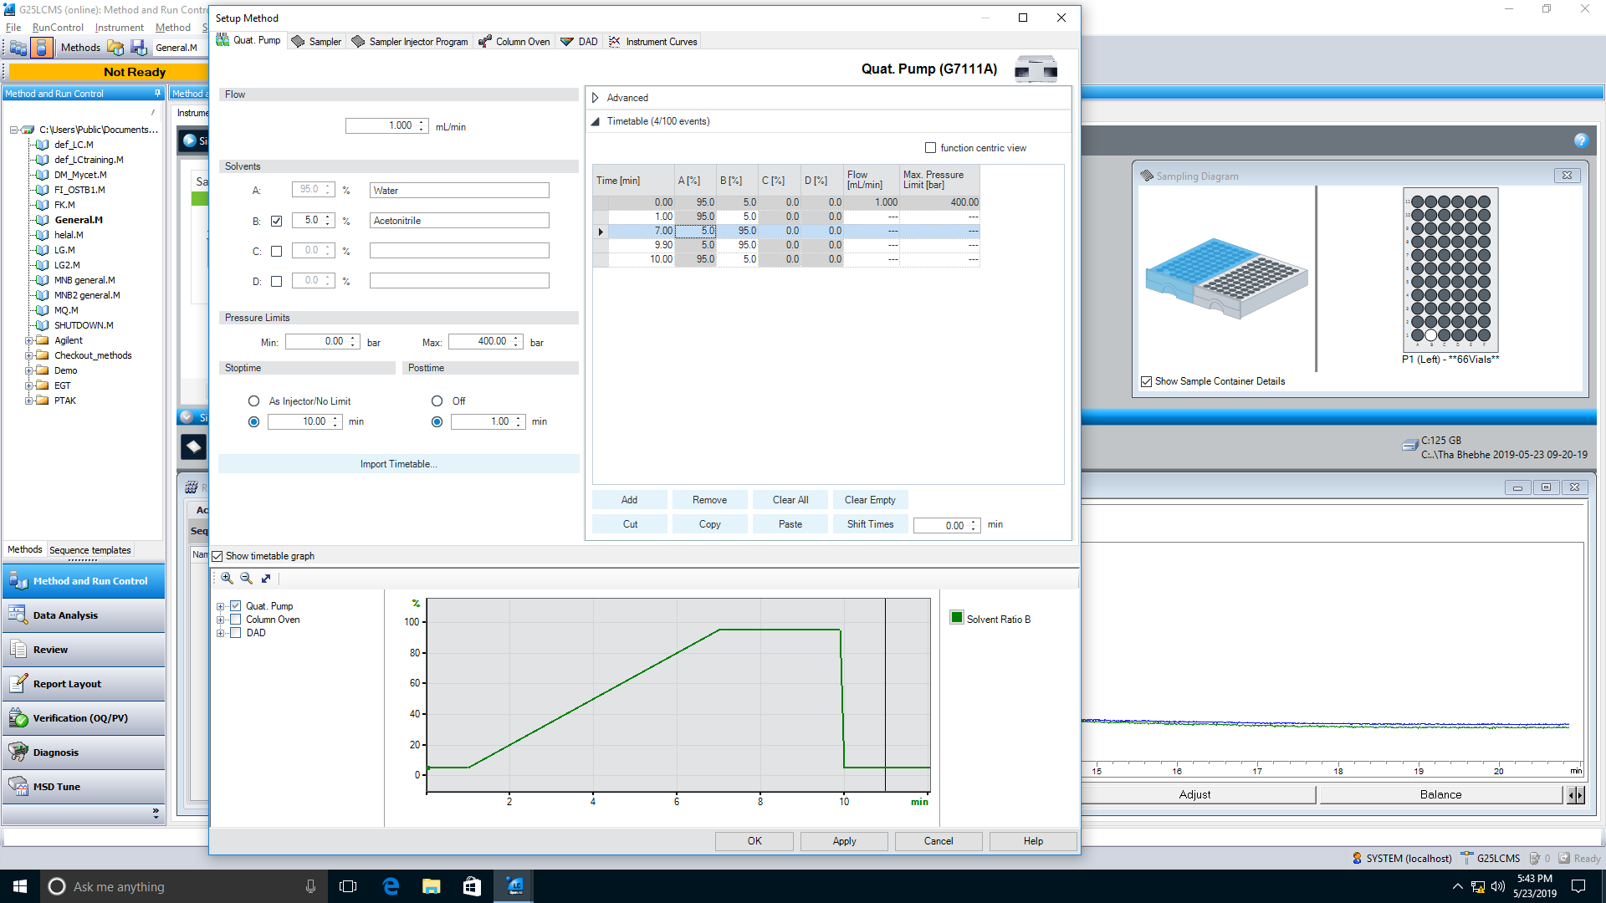

Set starting gradient composition here

Create gradient here by changing Time [min] and B [%]

Set Stoptime as the last time point of the gradient

* The mass detection settings can be edited under Instrument => Set up MSD signals…
* Choose the polarity of the detector (+ve ESI or -ve ESI)
* Choose the mass range appropriate for your desired compound (typically from 200 to 800, but expand if masses are higher or lower)
* The remaining settings can be left as default

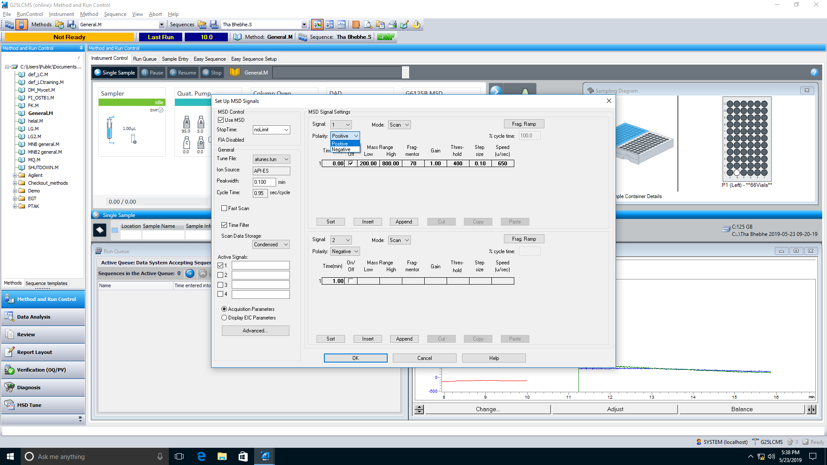

Set +ve or -ve ESI mode

Set mass detection limits appropriate for your compound

* To ensure that the instrument goes back to standby mode after a run, check under Method => Run Time Checklist… that Post-Run Command/Macro is selected and that it is set to Turn Instrument Standby
* Once done editing the method, right click the method name and choose “Save Method”

# **Fraction Collector Settings**

* Before running a sample, refill the test tube rack if empty
  + Hover over the fraction collector module to check the state of the tubes (blue circles indicate a fraction has previously been collected in that tube)

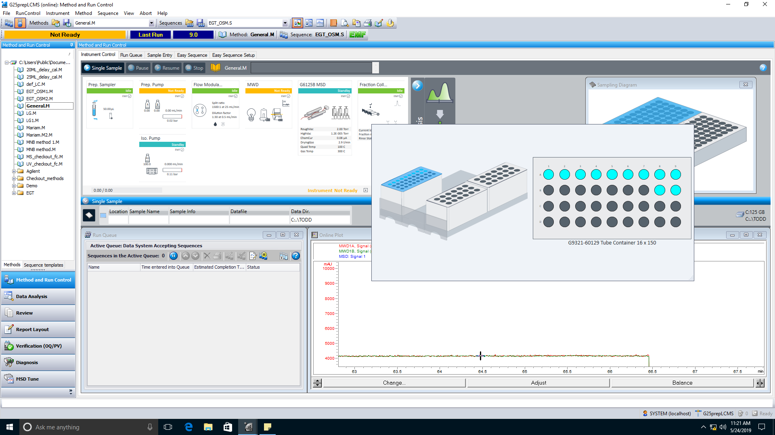

Hover the mouse over this image to see the status of the fraction volumes

Blue circles indicate the test tube has been used previously

Black circles indicate the test tube is empty

* + To reset the fraction volumes, right click the fraction collector module and choose “Reset Fraction Volumes…”
  + In the new window, click the top of the rack and press OK to reset the volumes to zero

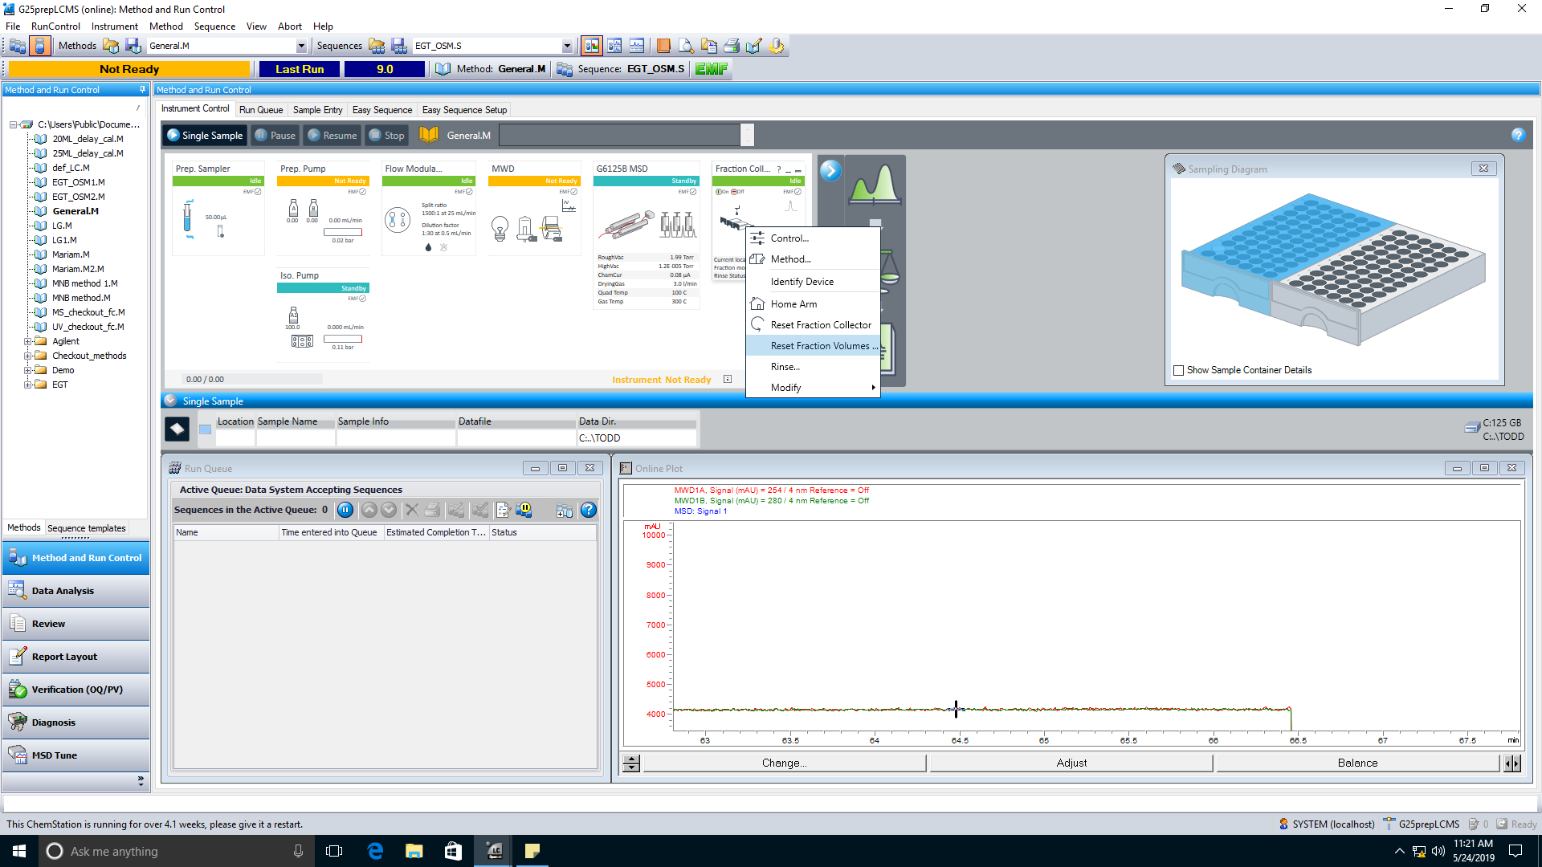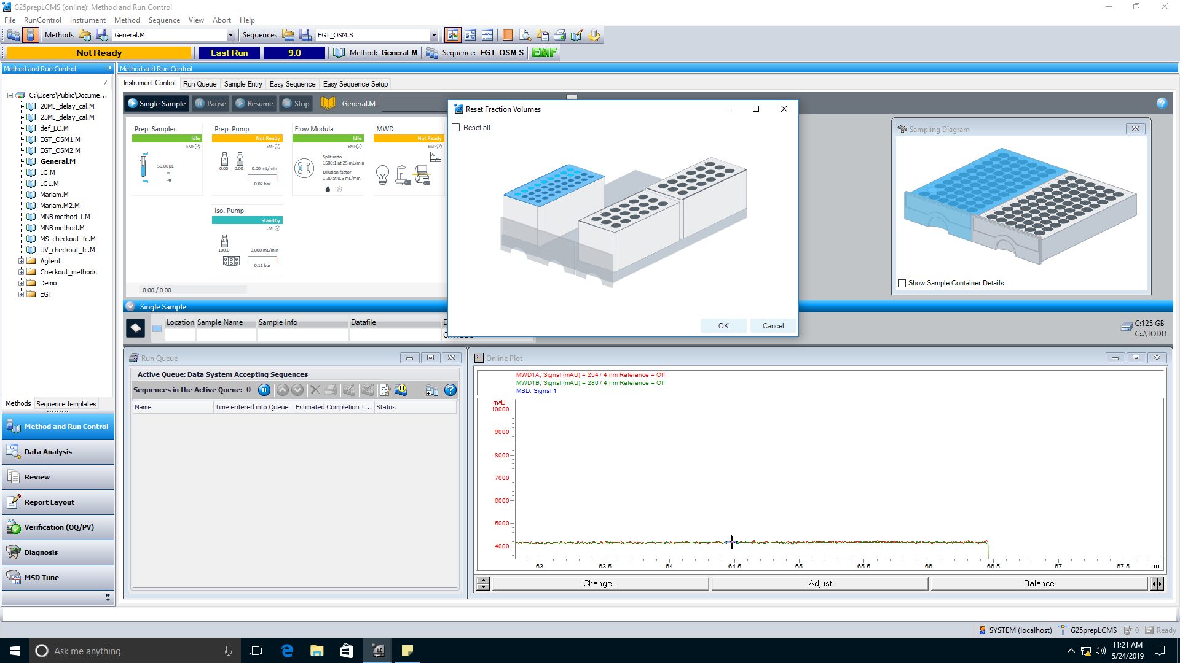

Right click this module and choose “Reset Fraction Volumes…”

Click the top of the rack to be cleared (will highlight blue) and press OK

* There is an additional tab in the method editor called “Fraction Collector”

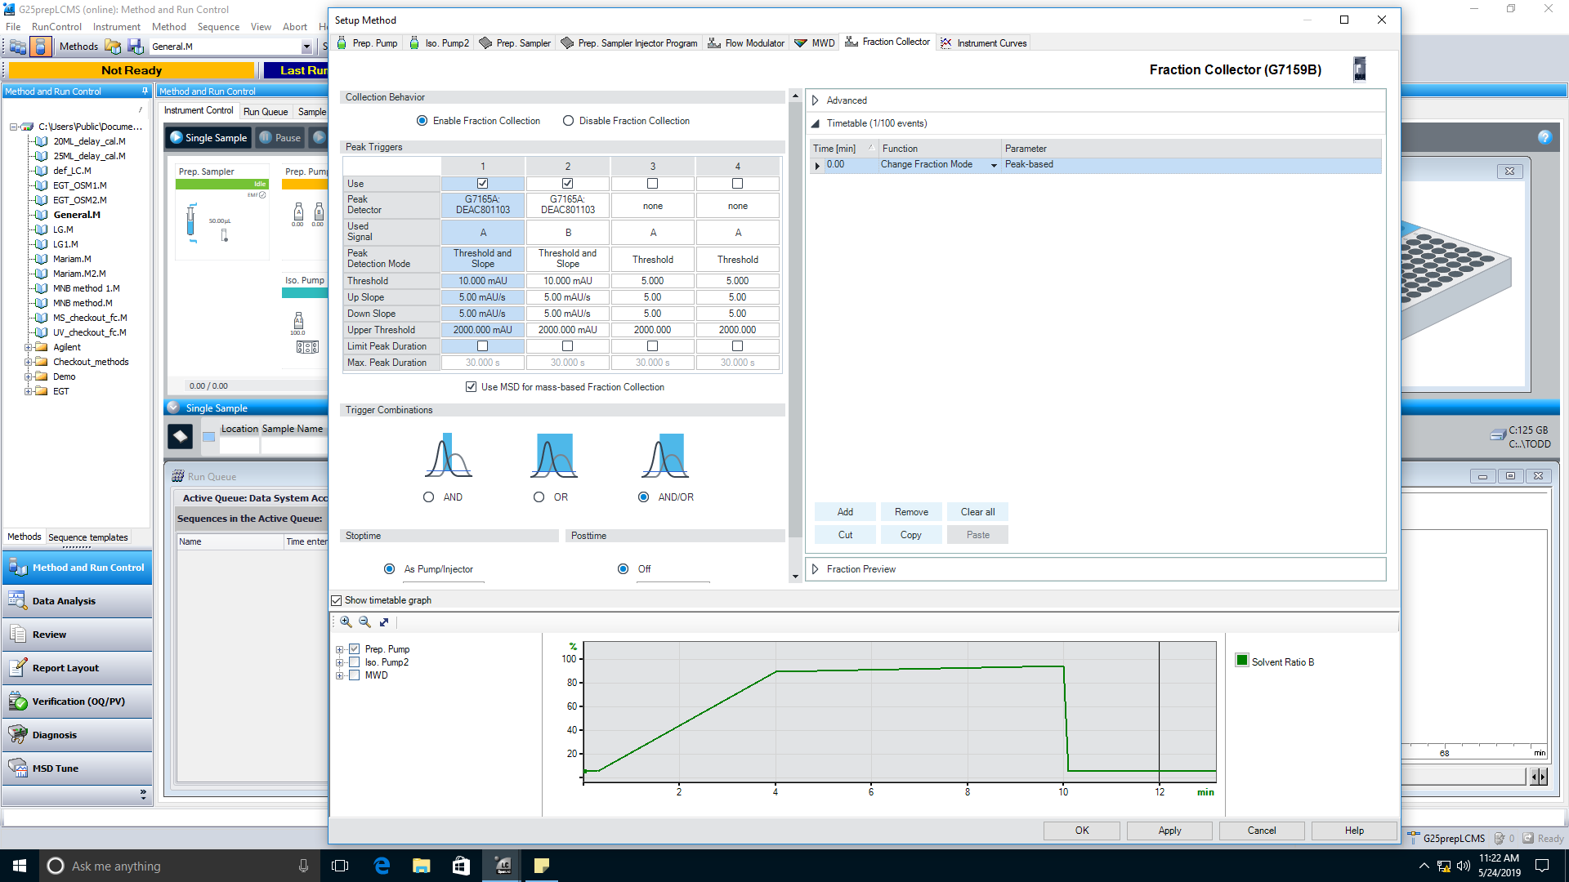

Additional settings for fraction collection

Set UV detection settings here

Choose this option if collection based on mass as well

* + Key settings are Peak Detection Mode, Threshold, Up Slope and Down Slope
* Extra settings for collection by mass are under Instrument => More MSD => Fraction Collection…
  + Select “Use sample target masses”
  + Choose Signal 1
  + Choose the appropriate Adducts (usually M+H and M+Na on +ve ESI mode)
  + Choose the detectors
    - MS only: Only collect when sample mass is detected
    - MS and other: Collect when sample mass and UV are detected
    - MS or other: Collect when sample mass or UV are detected
* Sample target masses are set in the sample info window (for single injections) or in the sequence table (for sequence injections)

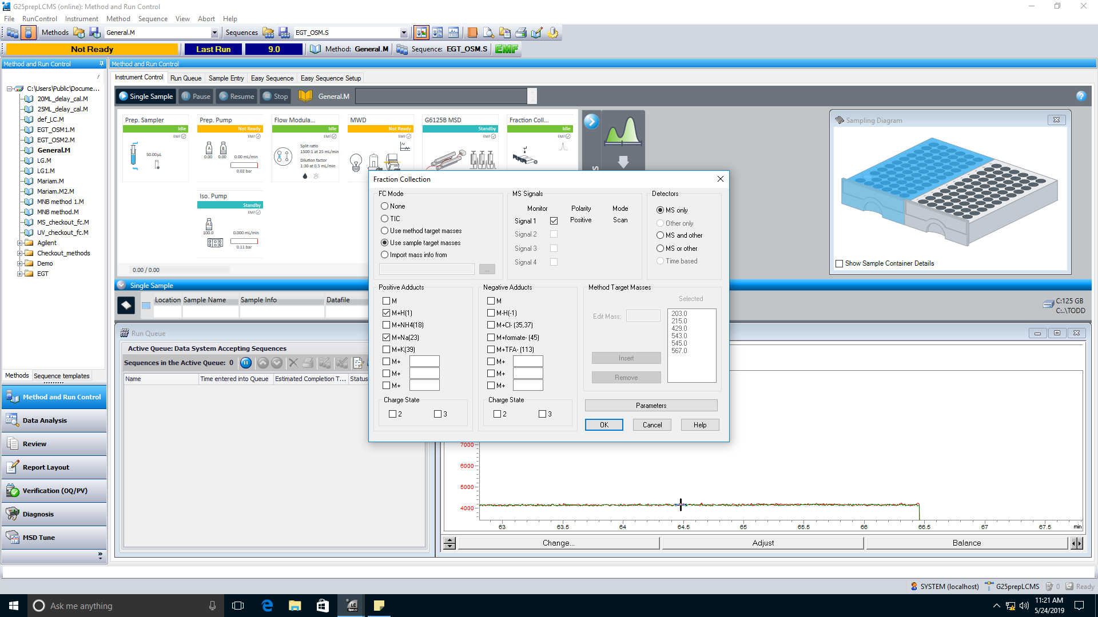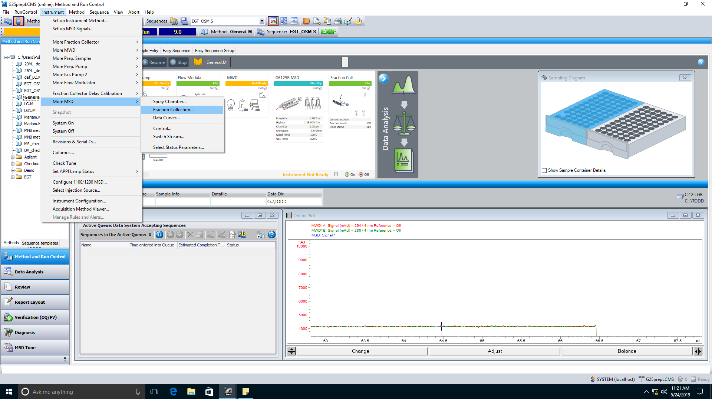

Select adducts for +ve or -ve ESI mode

Detection settings (collect only by MS or by MS and/or UV)

MS signals set in the MSD settings window (see above)

Sample target masses are set in the sample info window or the sequence table (see the respective sections)

# **Running a Single Injection**

* Load your method then:

1. Select the single injection mode
2. Click the blue square to enter the sample info window
3. Choose the appropriate subdirectory for your group
4. Click the drop-down arrow to choose a sample location (click the left or right plate and click the well location)
5. Enter a sample name
6. Set the injection volume (max 900 uL)
7. Enter the sample target mass
8. Click “Run Method”

7) Enter sample target mass

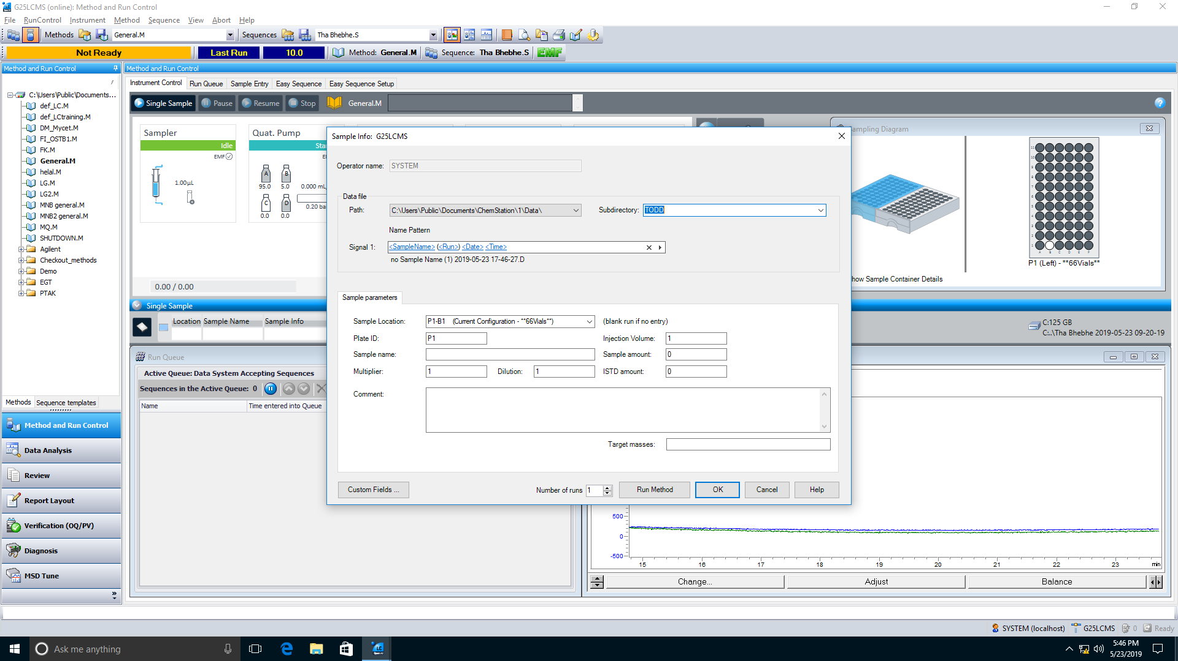

2) Click this blue square to open the sample info window

3) Select the subdirectory location where the data will be stored

4) Click the drop down arrow to choose the sample location (choose the left/right plate and click the well the sample is in)

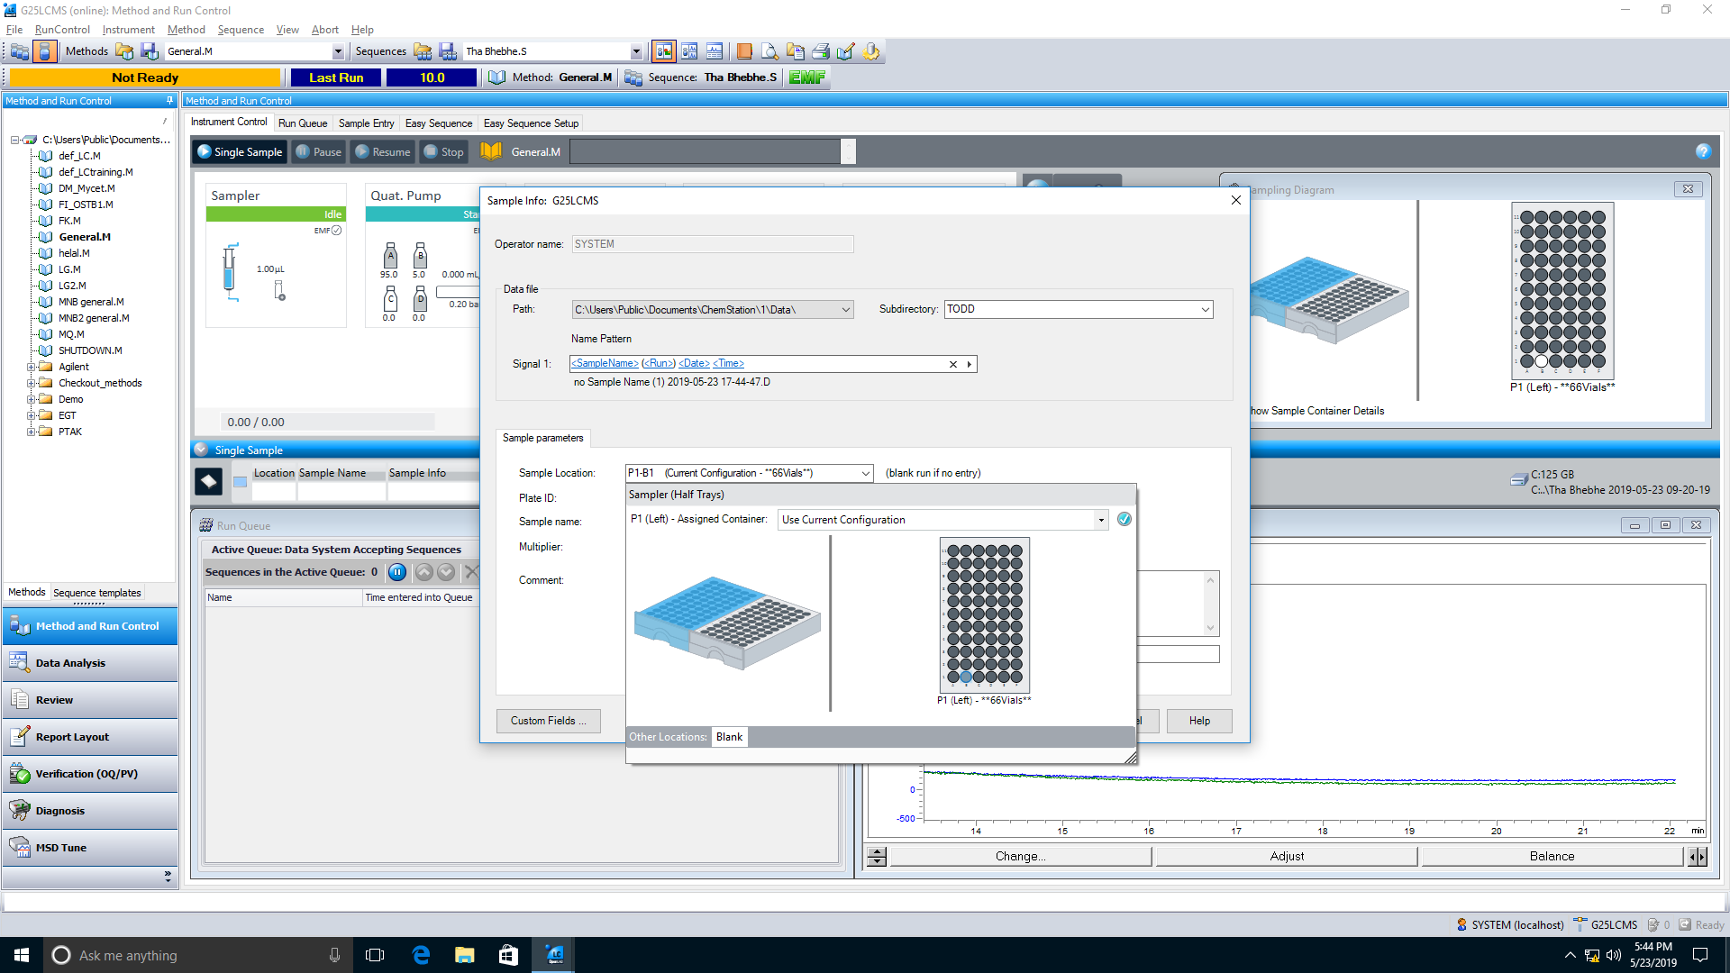

5) Enter the sample name

6) Set the injection volume

8) Run the sample

1) Choose the single vial button for a single injection run

# **Running Sequence Injections**

1. Select the sequence injection mode
2. Click the blue square to enter the sample info
3. Click the drop-down arrow to choose a sample location (click the left or right plate and click the well location)
4. Enter a sample name
5. Click the drop-down arrow to choose your method (if not on the list, click <browse> to find it)
6. Set the injection volume (max 900 uL)
7. Repeat for each sample
   * To add sample lines to the sequence, click the append lines button
   * To delete lines, select the line number and click the delete lines button
   * To automatically fill the info fields for other samples, select the column title and click the filldown button
   * If doing multiple injections of the same sample, change the value in the “Inj/Loc” column
8. Enter the sample target masses for each sample
9. Click “Run”

8) Enter sample target mass

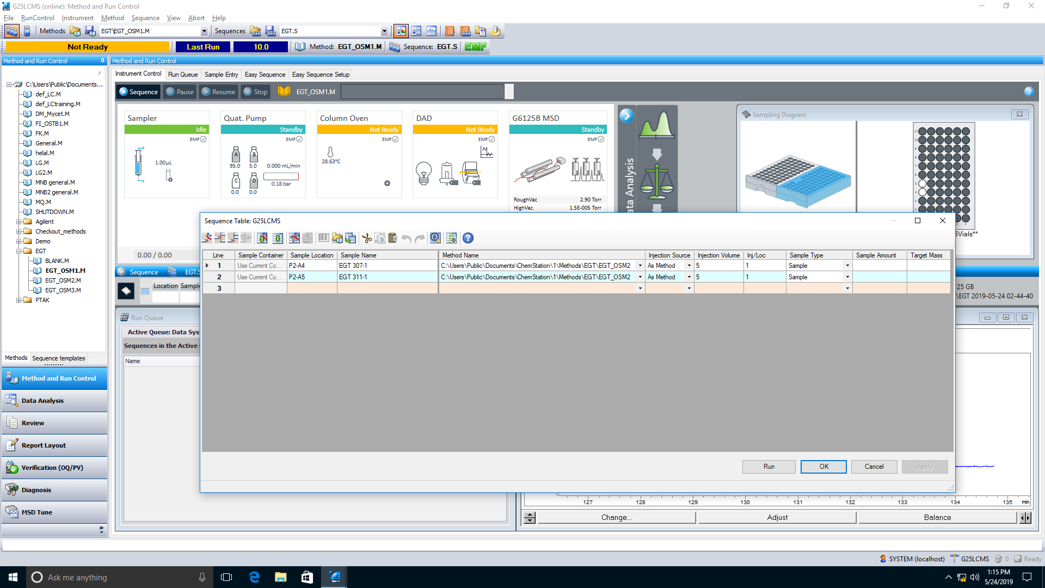

1) Choose the multiple vial button for a sequence run

3) Choose the sample location (same way as for a single injection run)

2) Click this blue square to open the sequence table

4) Enter the sample name

5) Click the drop down arrow and choose your method

6) Set the injection volume

7) Repeat with a new line for each sample

9) Run the sequence

Select a line and click this button to delete lines from the sequence

Click this button to add lines to the sequence

Select the column title then click this button to autofill the column info

# **Viewing the Data**

* To view the data, switch to offline mode
* Find the chosen subdirectory location
* For single injection runs, the file will be under Single Runs
* For sequence injection runs, the files separated in its own entry

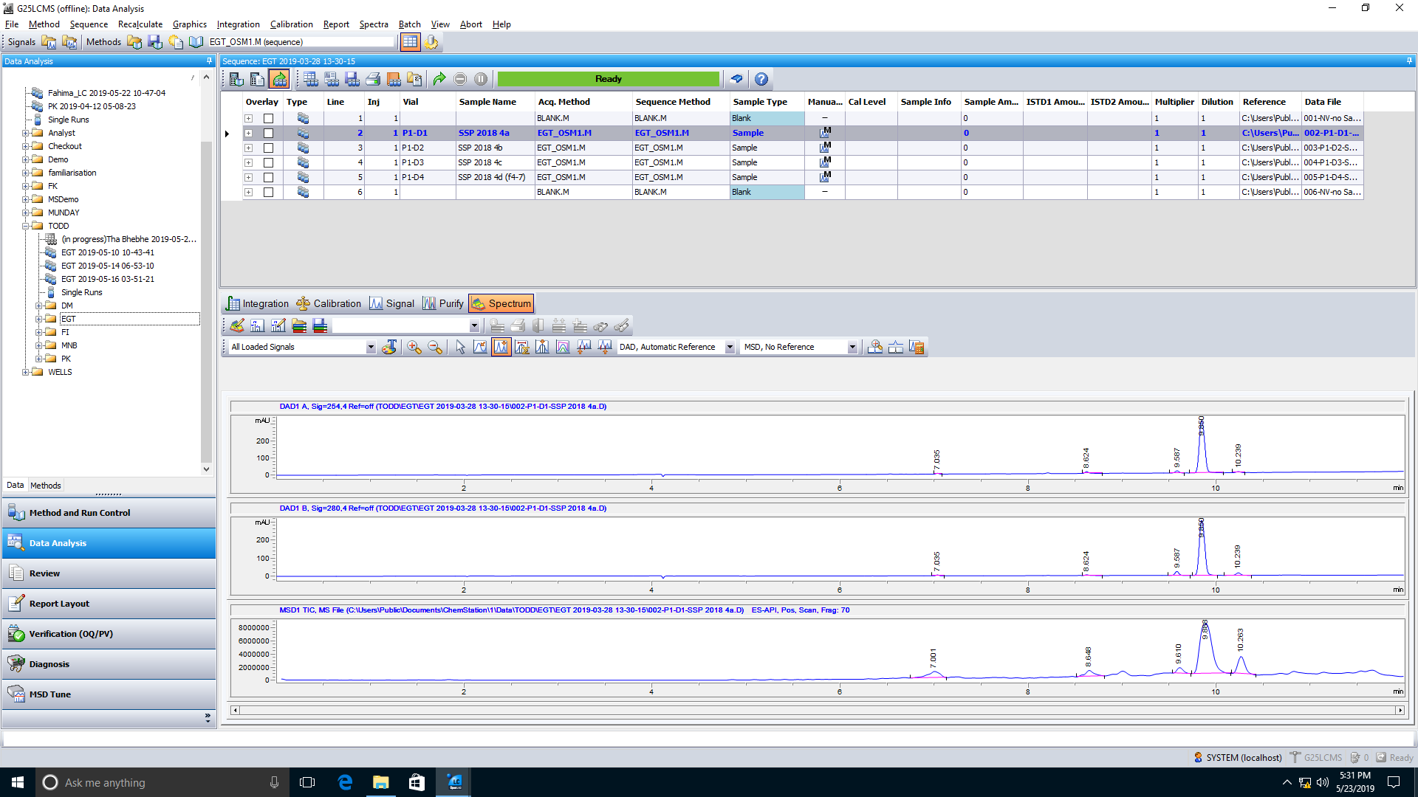

Find the subdirectory where the run data was stored

Sequence runs will be separated

All single injection runs will be under “Single Runs”

* Double click an entry to load the data

1. To view the mass spectra from the MSD TIC, first select Spectrum mode
2. Click the peak apex position button
3. Click on the peak on the MSD trace to view the mass

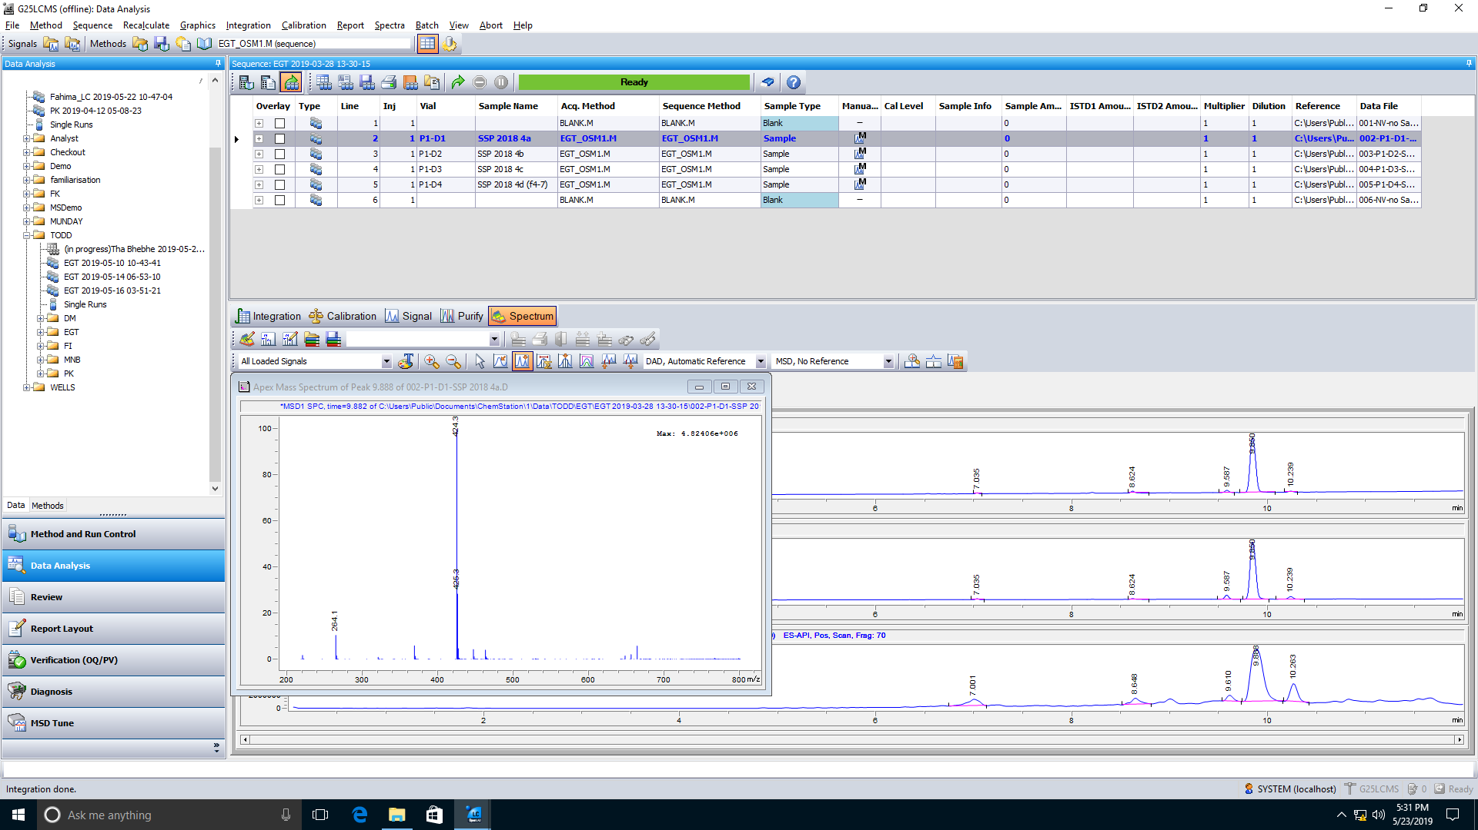

1) Select Spectrum mode

2) Select this button

3) Click the peak of interest on the MSD TIC

Mass spectra will display in a new window

* To save the report as a PDF, right click on the entry and choose Preview Report
* Save this PDF

Right click the entry and select “Preview Report” to view and save the PDF

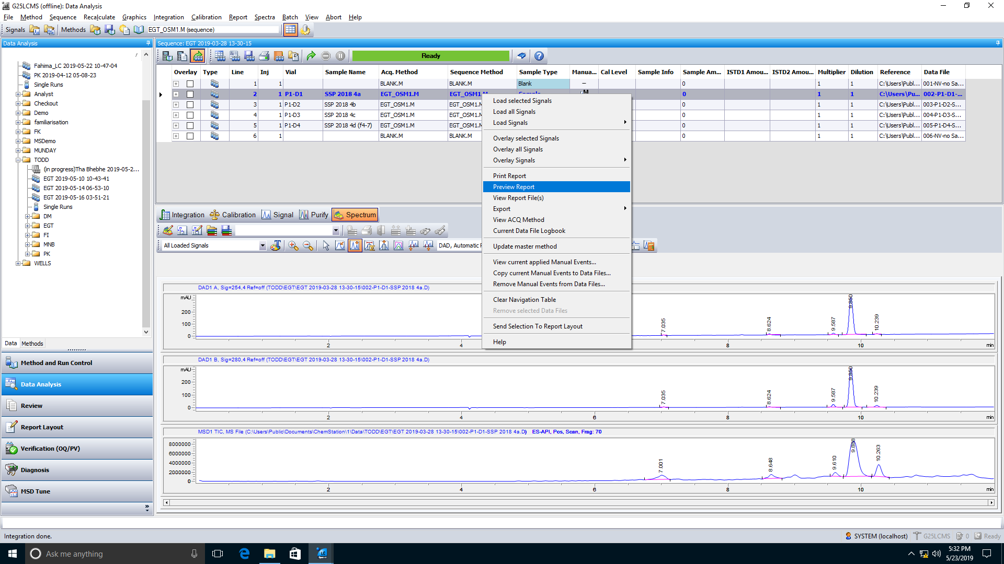

* If you have software such as MestreNova, you can copy the entire raw data folder and view the LCMS data elsewhere
* A shortcut to the raw data files can be found in the quick access menu
  + If no subdirectory was chosen, they will appear here
  + If a subdirectory was chosen, they will be in the respective folder

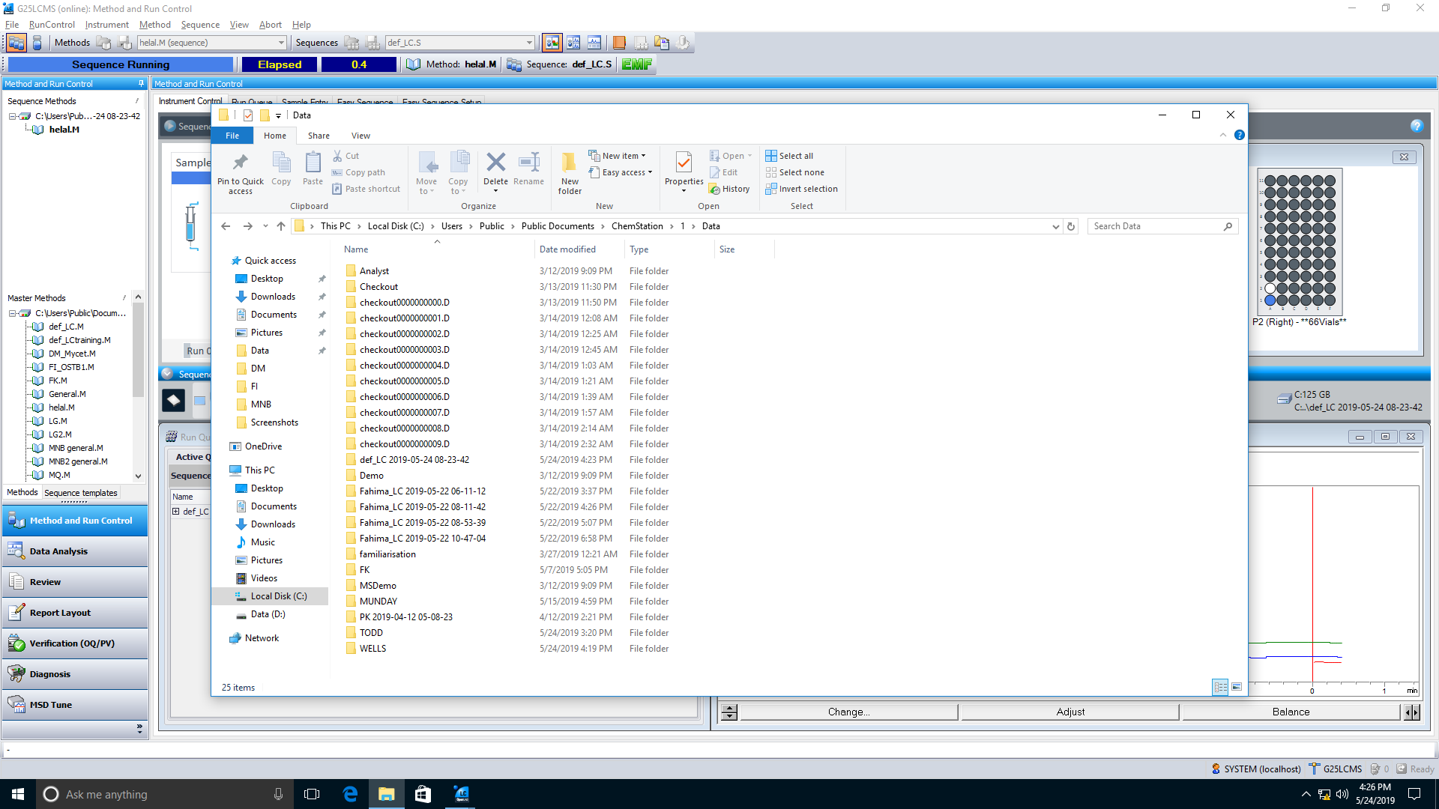

Shortcut to the raw data files